 | The CAMECA IMS 7f (*)  Tuning user’s guide  00 45 610 692 - Type 108 – Indice B
0000.doc
(This documentation is relevant for the IMS7f the number of which is equal or larger than 715)
Aug 2008: Modification of the Setup box: dt_fa, dt-ca and coefficients are added in the Max Area preset .
Index

Contents
1. The Tuning Principles 2
1.1 The Instrument Status File (ISF), MAP and OIP 2
1.2 The interface principles: Synoptics and Presets 4
1.3 The Hardware: Real time screen and dedicated keyboard 5
1.4 The Tuning software options 6
2. The Tuning Panels Description 7
2.1 The main menu bar 7
2.2 The Setup box 8
2.3 Loading and saving an ISF 9
Saving and loading Setup parameters 10
2.4 The synoptic panel 11
2.5 The preset boxes (1): The standard preset box 13
2.6 The preset boxes (2): The detector box. 14
2.7 The preset boxes (3): Apertures and Mass 15
2.8 The "Beam Position" and "Area Position" boxes 18
2.9 The OIP Panel 19
3. The ion source control 20
3.1 The Cs Source control 20
3.1.1 Overview 20
3.1.2 The Cs Source heating current normalization 20
3.1.3 The Cs Source Start Process 21
3.1.4 Cs Source Stop Process 22
3.1.5 The Start/Stop CS source panel 23
3.1.6 The Cs source set-up parameter panel 23
3.1.7 The Cs source links with the Setup file 26
3.2 The Duo Source control 26
3.2.1 Overview 26
3.2.2 The Duo source Start Process 27
3.2.3 The Duo Stop Process 27
3.2.4 The Duo source Start/Stop panel 28
3.2.5 The Duo source set-up parameter panel 28
3.2.6 The Duo source links with the Setup file 29
3.3 The E-GUN Source Control 29
3.3.1 Overview 29
3.3.2 The E-GUN Start Process 29
3.3.3 The E-GUN Stop Process 30
3.3.4 The E-GUN Start/Stop panel 30
3.3.5 The E-GUN setup parameter panel 30
3.3.6 The E-gun source links with the Setup file 31
4. The Tuning Reference guide 31
4.1 The ISF parameters list 31
4.1.1 The source parameters 31
4.1.2 The primary parameters 31
4.1.3 The secondary parameters 33
4.1.4 The NEG (E-Gun) Parameters 34
4.1.5 Imaging Parameters 35
4.2 The Synoptics Reference Guide 35
4.2.1 Sources 35
4.2.2 Primary column 36
4.2.3 Secondary 37
4.2.4 NEG 38
4.2.5 RAE 38
4.2.6 Apertures 38
4.2.7 Imaging 38
4.3 The Preset Reference Guide 40
4.3.1 Primary beam, Ion beam ON/OFF, Beam Pos 40
4.3.2 Maximum area 41
4.3.3 Raster, Raster ON/OFF 41
4.3.4 DTOS ON/OFF 42
4.3.5 Electronic gate, e-gate ON/OFF 43
4.3.6 Presets MCP_Image et MCP_Slit, FC et EM 43
4.3.6.1 MCP_Image et MCP_Slit Presets 43
4.3.6.2 FC and EM Presets 45
4.3.7 E-GUN ON/OFF 45
4.3.8 Motorized Aperture presets (Optional) 46
4.3.8.1 Entrance slit 46
4.3.8.2 Contrast Aperture 46
4.3.8.3 Field Aperture 47
4.3.8.4 Energy slit 48
4.3.8.5 Exit Slit 48
4.3.8.6 Mass resolution 49
4.3.9 The Raster Linearity Correction 49
4.4 The indexation reference guide 50
4.4.1 Valid + Source Accel HV 50
4.4.2 Valid + Sample HV 50
5. The Tuning setup file parameters 51

Contents ↑

The Tuning Principles

The Instrument Status File (ISF), MAP and OIP

The IMS 7f is computer controlled, except for the slits and apertures for instruments in the standard configuration. All the instrument parameters are contained either in the Set-up file or in the Instrument Status File (ISF), except the magnet setting, or in other words the mass selection.

The Set-up file does not contain only instrument parameters; It contains also a lot of software routine parameters (e.g. the threshold from switching from EM to FC in an analysis). Intrument parameters which are contained in the Set-up file are those which do not depend on the MAP, either they are expected to be fix all along the instrument life (e.g. the MCP phosphorus screen voltage) or there depend only on a consumable device aging (e.g. the EM voltage or the Cs source reservoir current). Some Setup file parameters can be read and edited from the Tuning interface or from the Tool interface. All the Setup file parameters can be read and edited from the Setup file viewer. Refer to the Setup file user's guide.
An Instrument Status File (ISF) contains the set of the instrument settings corresponding to a required physical configuration. This required physical configuration determines a set of Main Analytical Parameters (MAP). See below the list of MAP. An ISF does not correspond to a single instrument configuration. The selections which can be done within a given ISF (e.g. the primary raster size, or the exit slit width) are called Optional Instrument Parameters (OIP).
In this document, Preset and OIP have very similar meanings. Generally, each preset or OIP consists of several parameters. The principle is to constitute a reduced set of selection for simplifying the way of operating the instrument.

MAP list
- The nature of primary ions (Cs+/O2+/O-)
- The primary source location (36° col/60°col)
- The primary accelerating voltage (e.g. 4kV)
- The impact energy (e.g. 8 keV)
- The secondary ion polarity (+/-)
- The secondary ion accelerating voltage (e.g. 3 kV)

OIP list
With the Tuning interface, all the presets can be selected separately from the main Tuning menu bar. See below the sections § The main menu bar, § The preset boxes (1) and § The preset boxes (2) . An overall configuration can also saved and restored from the OIP Panel. See below the section § the OIP panel.
It is explained in the Analysis software user's guide that a set of OIP must be defined for each analysis. These OIPs will be automatically loaded at the beginning of an analysis.
OIP | Way of use in Tuning | Way of use in Analysis
Primary beam (1/2/.../9) | § Primary Beam | selectable
Max Area (1/2/.../9) | § Max Area | selectable
Raster (µm) | § Raster  Discrete selection (1/2.../9) in the Preset pad. Editable in the OIP box. | editable in µm
DT (ON/OFF) | § DT ON/OFF | ON/OFF
E-Gate (%) | § E-gate  Discrete selection (1/2.../9) in the Preset pad. Editable in the OIP box. | editable in %
Detector (Slit/Ima/FC/EM) | § detector presets | FC or EM are defined for each analysed mass.
Slit and Image zoom | § detector presets | Na
Entrance Slit (µm) | § Motorized apertures  Discrete selection in the OIP box. | editable in µm
Energy Slit (eV) | § Motorized apertures  Discrete selection in the OIP box. | editable in both position (eV) and width (eV)
Exit Slit (MR) | § Motorized apertures  Discrete selection in the OIP box. | editable in MR
Contrast Aperture (1/2/3/4) | § Motorized apertures | selectable
Field Aperture (1/2/3/4) | § Motorized apertures | selectable
Mass resolution | § Motorized apertures  Not available from the OIP panel | If option "Automatic", this selection replaces the selection of the Exit Slit

Contents ↑

The interface principles: Synoptics and Presets

- It is possible to assign the 3 dedicated keyboard thumbwheels to a set of 3 parameters either with the synoptic box or with the different preset boxes.
- The parameter current values activated by the keyboard thumbwheels are diaplayed in the Real Time Screen.
- Most of the ISF parameter controlling directly the instrument are available from the synoptic panel.
- In each preset box, only the parameters included in the considered preset are available. This box is purposed for building the preset.

The Hardware: Real time screen and dedicated keyboard
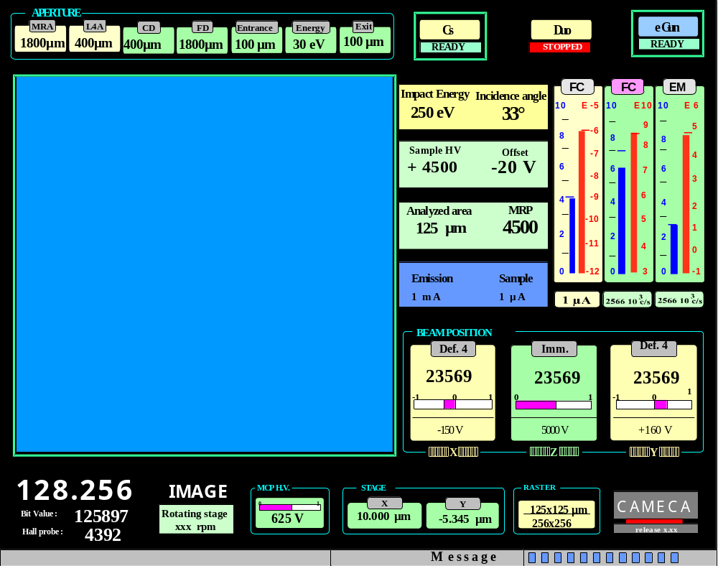

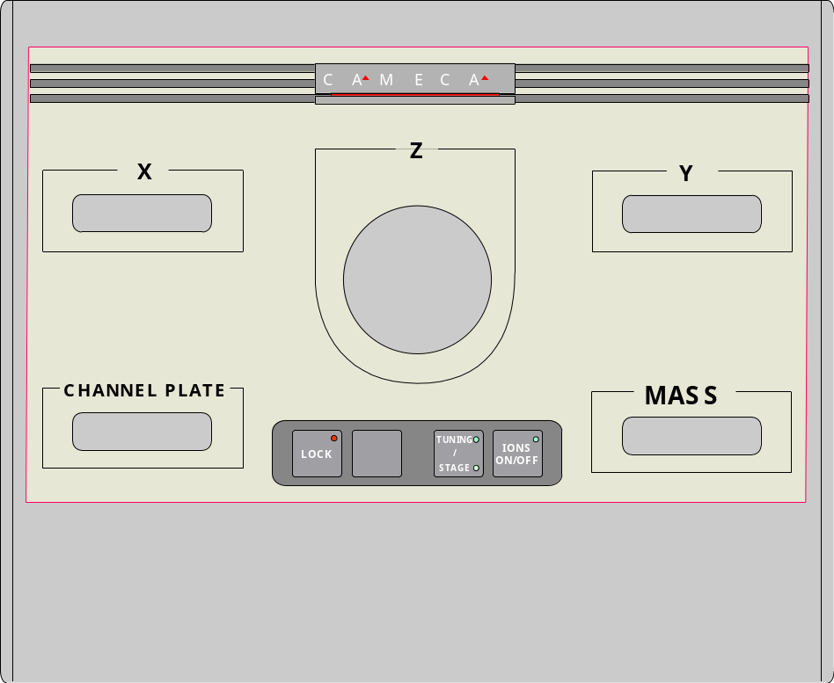
Contents ↑

The Tuning software options
Path: Tuning (Main menu bar + Setup + Options)
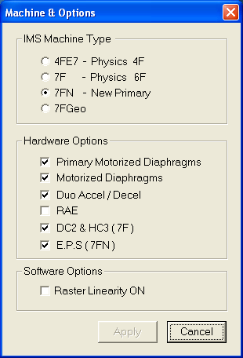 | For IMS7f >715, select  - 7FN  - Primary Motorized Diaphragms  - Motorized Diaphragms  - DC2 & HC3 (7F)  Select also, if the accessories are implemented on the instrument  - Duo Accel-decel  - RAE  7fGeo and EPS must be selected only for the IMS 7f-Geosciences.

The Tuning Panels Description

The main menu bar
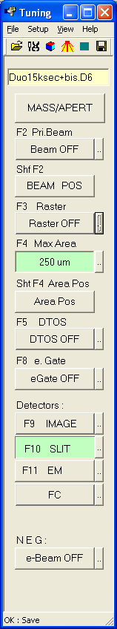 | File displays the selection menu open/save/save as/Print/Print Setup. Refer below to the section § Loading and saving an ISF  Setup displays the selection menu Sources/ Work with /options /parameters  View displays displays the menu Tool bar/Status. See below  opens the ISF loading box.  saves the current instrument configuration with the displayed filename. Refer to the section § Loading and saving an ISF.  opens the synoptic panel.  opens the OIP panel.  opens the Start/Stop CS source panel or the Start/Stop Duo panel  refreshes the link between the workstation and the µProcessor.  displays the current ISF label .  F1 MASS opens the Mass and aperture box.  displays the current Primary beam preset label. Clicking the button switches the primary beam ON/OFF (equivalent to the dedicated keybord button).  opens the Primary beam preset box.  BEAM POS opens the Beam Position box  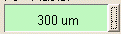 displays the current Raster size preset label. Clicking the button switches the Raster ON/OFF.  opens the Raster preset box.  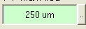 displays the current Max Area preset label.   opens the Max Area preset box.  Area Pos opens the Area Position box.  DTOS OFF/ON switches the dynamic transfer DT ON/OFF.  opens the DT preset box.  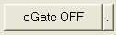 switching the eGate ON/OFF. If eGate=ON, the field displays the eGate ratio (%). opens the eGate preset box.  Image/Slit/EM/FC selects the detector preset. Both the Image and Slit fields display also the current zoom preset.  opens the detector preset box.  e-beam ON/OFF switches the NEG ON/OFF.
View/Tool bar allows to display or to suppress the icon bar 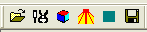
View/Status allows to display or to suppress the bottom line

The Setup box
Path: Tuning (Main menu bar + Setup + Parameters)
This panel allows to edit some parameters which will be registered in the setup file when saving the ISF
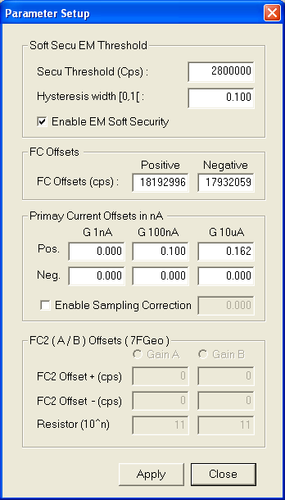 | Secu Threshold and Hysteresis:  These parameters control the EM/FC switching conditions along an analysis according to the secondary ion optics user's guide/EM-FC switching  If Enable EM Soft Security is notched, the detector switches automatically from EM to FC in the same conditions as with an analysis.  FC offsets are the secondary FCs offset secondary FCs offset.  See also Tools/FCS meas  Primary Current offsets are targetted to take into account that primary FC offsets in the sampling mode may be different from the static mode. This is due to some electrical leakage problems that can be pointed out by a residual value when the static offset is correctly compensated (Refer to Tools/FCp meas) and when the ion source is set off. Enter this residual into the corresponding editing field.  FC2 Offsets is for the 7fGeo option, which includes an extra secondary FC channel with 2 possible gains.

DT FA Factor (kfax, kfay) and DT CA Factor (kcax, kcay)are the coefficients which are linking both transfer deflection DT1 and DT2, according to the relationship
dt_fax = dt1x + kcax dt3x
dt_fax = dt1y + kcay dt3y
dt_cax = kfax dt1x + dt3x
dt_cax = kfax dt1x + dt3x
Refer to the secondary ion optics user's guide/ linking dt-fa and dt_ca
# | Set-up Label | Comments
414 | THR_SECU_SOFT_VAL | Refer to the second ion optics user's guide/ detectors
387 | FCs Offset (pos. polarity) | Refer to the second ion optics user's guide/ Faraday
607 | FCs Offset (neg polarity) | Refer to the second ion optics user's guide/ Faraday
1033 | COEF DT FA X | Refer to the second ion optics user's guide/ linking
1034 | COEF DT FA Y | Refer to the second ion optics user's guide/ linking
1037 | COEF DT CA X | Refer to the second ion optics user's guide/ linking
1038 | COEF DT CA Y | Refer to the second ion optics user's guide/ linking

Loading and saving an ISF
It is possible to load an ISF either by clicking the icon or by selecting the menu File/Open.

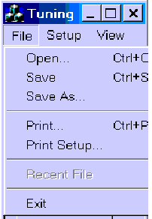 | - Open opens the ISF loading box.  - Save saves the Instrument settings under the current filename displayed at the top of the Tuning menu bar. It saves also the Setup parameters in the setup file.  - Save as opens the ISF saving box for saving the instrument setting under a new name. It saves also the Setup parameters in the setup file.  - Print prints the ASCII ISF  - Print Setup allows to set the printer configuration

When saving a file, the suffix C6/D6 is added to the filename according the source selection: Cs/Duo. The source selection can be done either by loading an ISF of the required type - that is the normal way - or by selecting the source with Setup/Work with (Tuning bar top), that must be done only the first time a new type ISF is created for the instrument.

The ISF Loading box
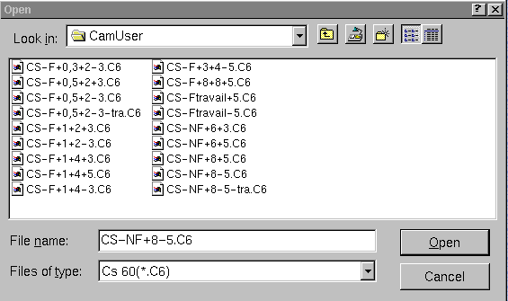
Select the required ISF and click Open for loading the ISF.
The field Files of type allows to sort the ISF according to their suffix C6/D6 which corresponds to the ion source location (Cs/Duo).
Loading an ISF loads also the instrument setting contained in the Setup file.

Saving and loading Setup parameters
# | Set-up Label | Comments
718 | Working ISF | Tuning/Open
719 | Default ISF Folder | Tuning/Open

Contents ↑

The synoptic panel
Clicking the icon in the top of the Tuning menu bar opens the synoptic panel displayed below.

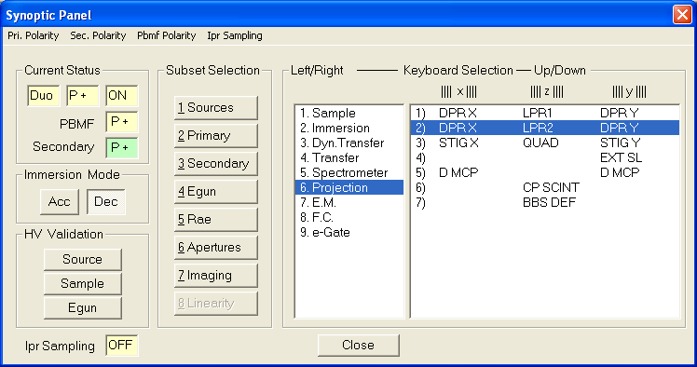

For assigning a given parameter to a dedicated keyboard thumbwheel, it is necessary to follow a path, e.g. Secondary/Projection/3) for assigning the kbd thumbwheels to
(STIGX, QUAD, STIGY)
Secondary , Projection and 3) are selected on the right hand side of the box.
Refer to the section § The Synoptics Reference Guide for the overall classification of all the parameters available with the synoptic panel.

Polarities allows to switch the secondary polarity, the primary polarity and also the primary beam mass filter polarity.
Current status displays the current source status.
Acc/Dec IMM allows to switch the immersion lens mode from accel to decel.
Valid Source HV opens the Valid Source HV Box. (See below)
Valid Sample HV opens the Valid Sample HV Box. (See below)
Valid Egun HV opens the Valid Egun HV Box.

The Valid Accel HV and the Valid Sample HV boxes
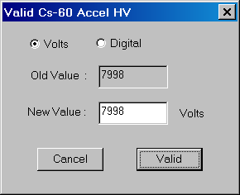 | 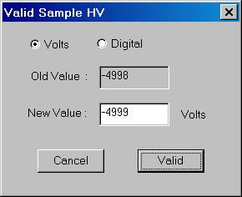
Valid Accel HV is purposed to transform an ISF tuned for a given Accel HV (Old Value) to an ISF suited for a new Accel HV (New Value).  - Load the old ISF onto the instrument.  - Assign the kbd thumbwheel to Accel HV by selecting Synoptic/Primary/Sources.  - Set the Accel HV to the required value (Caution, if the Cs Source is used, it is necessary to tune the heating currents by hand)  - Open the Valid Accel HV box in the synoptic panel.  - The previous Accel HV is then displayed in the Old Value field while the new value is displayed in the New value field  - Click Valid.  - The overall primary settings are transformed according to the section § The indexation reference guide  - Tune the primary last lens (LPRIM4) and Beam Pos X&Y  - Save the new ISF with a new name.  Refer to the Primary ion optics user's guide. | Valid Sample HV is purposed to transform an ISF tuned for a given Sample HV (Old Value) to an ISF suited for a new Samplel HV (New Value).  - Load the old ISF onto the instrument.  - Assign the kbd thumbwheel to Sample HV by selecting Synoptic/Secondary/Sample and Raster.  - Set the Sample HV to the required value (Caution, if the Cs Source is used, it is necessary to tune the heating currents by hand)  - Open the Valid Sample HV box in the synoptic panel.  - The previous Sample HV is then displayed in the Old Value field while the new value is displayed in the New value field  - Click Valid.  - The overall primary settings are transformed according to the section § The indexation reference guide  - Tune the primary last lens(LPRIM4) and Beam Pos X&Y  - Save the new ISF with a new name.  Refer to the Secondary ion optics user's guide.

Contents ↑

The preset boxes (1): The standard preset box
The "Standard preset box" can be opened by clicking  associated either to the button Primary beam or Raster or eGate or Max Area or DTOS.
The "Standard preset box" consists of the Preset pad, at the left hand side, and the Calib box, at the right hand side, which must be opened only for modifying the content of a preset.
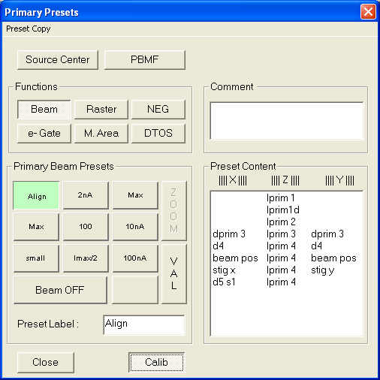

- The buttons Beam, Raster, eGate, Max Area and DTOS allows to select the required preset pad.
- Source Center assigns the kbd X&Y thumbwheels to (DPRIM1X, DPRIM1Y).
- Preset Copy is purposed for copying the current settings to any preset number; it displays the selecting menu 1/2/3.../9, corresponding to the following positions on the keypad.
7 | 8 | 9
4 | 5 | 6
1 | 2 | 3
The current settings will be memorized in the selected preset number.
- Preset label edits the preset label. Valid the label with the computer keyboard Enter.
- Valid is enabled if Calib has been clicked. It modifies the preset content.
- Calib opens or closes the right hand side calib box.
- The Calib box allows to assign the kbd thumbwheels to a selected line in order to modify a preset. The preset will not be actually modified if the calib box is closed without having clicked Valid.
- Cancel closes the box.

For the rules specific to each preset pad (i.e. the Max Area preset labels must be numerical, Valid+Raster has an effect onto all the presets ...), refer to the section § the preset reference guide .

Contents ↑

The preset boxes (2): The detector box.
The "Detector box" can be opened by clicking  associated either to the button Slit or Image or FC or EM .
The " Detector box " consists of the Preset pad, at the left hand side, and the Calib box, at the right hand side, which must be opened only for modifying the content of a preset.

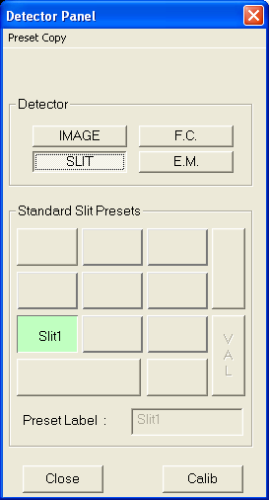

The rules of these 4 types of detector presets are slighly more complex and intricated than the standard rules. Refer to the section § Slit, Image, FC, EM Presets. Note, for example, that if Slit or Image are selected, up to 9 "Zoom" presets can be defined, but only Lpr1 and Lpr2 are specific to each zoom preset while the other parameters Lcoup, Stig.. are common for all the Slit zoom presets or for all the Image zoom presets.
Contents ↑

The preset boxes (3): Apertures and Mass
Mass functions
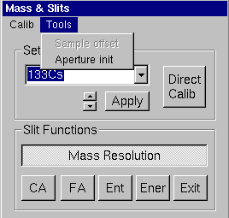 | Calib displays Shift Mass/Call Calib.  Shift Mass shifts all the [M, B] table by according to the ratio (M1/M2) by modifying the Mas Mass in the [B, k(B)] table (Refer to the secondary ion optics guide for information about the [B, k(B)] table)  Call Calib opens the Mass calibration routine.  Tools/Aperture init opens the Aperture Init box (See below)  Set Mass edits the required mass, validated by the computer kbd Enter or by clicking Apply.  Apply loads the edited mass to the instrument.  increments the mass of +/- 1 amu  Direct Calib adds the line (M, B) to the current [M, B] table.

Apertures functions
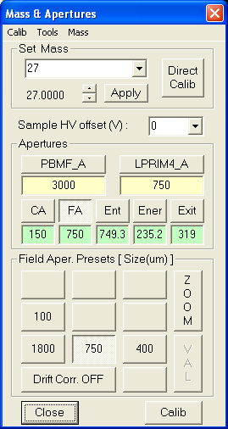

These presets control directly the instrument only if the Motorized Slits and Apertures option is present. However, before starting an analysis, it is advisable to select the presets corresponding to the status of the instrument, since these information is stored in the data files.

CA/FA/Ent/Ener/Exit allows to assign the aperture preset pad to the selected aperture (CA stands for Contrat Aperture. FA stands for Field Aperture. Ent stands for Entrance slit. Ener stands for Energy slit. Exit stands for Exit slit. For the specific rule for each aperture, refer to the section § Motorized aperture presets. For example, it is explained that the Exit Slit and the Entrance slit presets cannot be changed, that Exit Slit is expressed as a MR (Mass resolution) while Entrance Slit is expressed in µm.
For any selection of CA/FA/Ent/Ener/Exit, Calib does not open the Calib box but assigns the kbd thumbwheels to the selected aperture axis.
Valid modifies the preset content, if the Valid is enabled, that is the case for CA, FA and Ener.
Mass resolution can be selected instead of CA/FA/Ent/Ener/Exit. Mass resolution is actually a "super-preset" which combines the 3 slits: Exit Slit, Entrance Slit and Energy Slit. Any value of Exit Slitand Entrance Slit can be memorized in a Mass Resolution preset while in the case of the Energy slit, only a preset (i.e. a couple X, W) can be stored.

Remark 1: The 3 slits labels cannot be entered since they are determined automatically from the actual aperture position. The Exit Slit label is in MR, the Entrance slit label is in µm and the Energy Slit in eV. If the labels are observed to be wrong, the expert operator must check the slit offset (in the Interface window, select the utility menu "Aperture and Stage", and there it is possible to select Entrance width offset/ Exit width offset/ Energy width offset/ Energy slit position). These functions must be activated after the operator has set respectively the Entrance width, the Exit width and the Energy width to zero or the low energy edge to axis.

Remark 2 After an aperture supply switch off, the aperture positions taken into account by the instrument and displayed in the user'interfaces are no more correct. It is necessary to activate Init procedures with the Aperture Init box.

The Aperture Init box
Can be opened from the Aperture and Mass Box. Select Tool/Aperture Init.
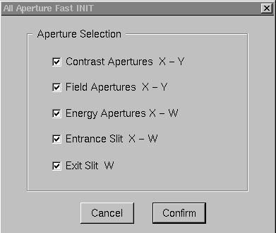

Contents ↑

The "Beam Position" and "Area Position" boxes
The Beam position box and the Area position box can be selected by clicking the so-labelled buttons in the main Tuning menu bar.
The Beam Pos box must be used whenever the operator wishes to shift all the Primary beam presets of the same value for the 3 parameters Beam Pos X, Beam Pos Y, Last Lens. This is recommended, for example, when it was checked that all the Primary Beam presets were well-centered and that it is required to shift all the presets either for building a new ISF or to compensate some external parasitic effect (e.g. an electrostatic edge effect).
The Area Pos box must be used whenever the operator wishes to shift all the Mawx Area presets of the same value for the 3 parameters DTR X, DTR Y, Immersion Lens.

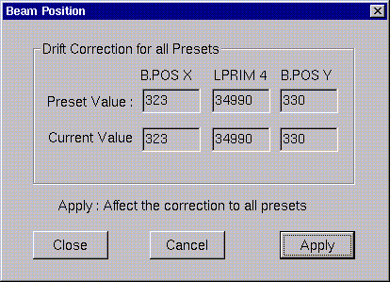 | 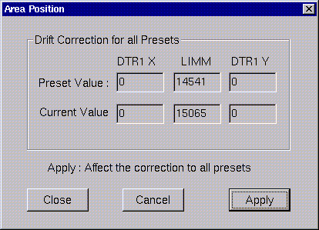
The kbd thumbwheels are assigned to Beam Pos X, Lprim4, Beam Pos Y. The operator has modified some of these settings.  Apply Shifts all the Primary Beam presets.  Cancel does not modify any Primary Beam presets. | The kbd thumbwheels are assigned to DTR X, Immersion Lens, DTR Y. The operator has modified some of these settings.  Apply Shifts all the Max Area presets.  Cancel does not modify any Max Area presets.

Contents ↑

The OIP Panel
Clicking the icon in the top of the Tuning menu bar opens the OIP panel displayed below.
This panel allows to store 9 set of OIP, or in other words 9 instrument configurations, all compatible with the same ISF, i.e. corresponding to the same MAP. For example, it is convenient to store a setting for saving the ISF, with all the apertures widely opened, and the Image mode selected, another setting corresponding to good conditions of sample imaging (small CA, narrow energy width), and finally another setting for checking the Entrance slit image (reduced FA, Slit mode)
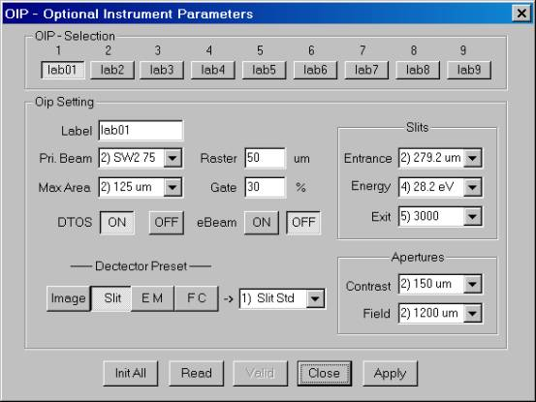

- At the top of the box it is possible to select 1 OIP setting among 9 possible. When selecting an OIP setting, the content of this setting is displayed in all the box fields.
- An OIP setting can be modified either by a Read operation or by modifying directly the OIP box.
- The in-the-box OIP setting modification is possible by editing the fields Label, Raster, Gate, by selecting a preset in the combo box Pr.Beam, Max Area, detector, Entrance, Energy, Exit, Contrast, Field and by selecting a button Slit/Image/EM/FC.
- Init All fills all the settings with default values.
- Read updates an OIP setting with the current configuration.
- Valid validates an OIP setting modification after an In-the-box modification.
- Close closes the OIP box.
- Apply loads the selected setting to the instrument.

Contents ↑

The ion source control

The Cs Source control

Overview
The Tuning Cs Source control panels allow the operator to set the Cs Source High Voltage, ionizer current and reservoir current . The Cs Source High Voltage (or Accel HV) is chosen by the user according to analytical requirements. Both the ionizer and the reservoir currents are depending on the kind of Source (Refer to The CAMECA ion source user’s guide). The total Cs Source current (ionizer + reservoir + leakage currents) is not readable from the Tuning interface, but the leakage current can be read in the panel Tool/Diagnostic. The level of this leakage current gives an idea of the source aging.
In the the Ion source user's guide, it is explained that for a given source accel HV, the reservoir current must be increased along the source life for keeping the same spot density. This increase is not achieved automatically. Practically, the user is advised to increase the reservoir current with the thumbwheels (See the section § Synoptics/ Sources)
The way of storing the current heating conditions along a source life and the determination of these heating conditions for a given accelerating voltage are documented below in the sections § The Cs Source heating current normalization
Starting the Cs source, stopping it or switching the accelerating voltage involve automatic process under computer control. This is documented in the section § The Cs Source Start Process

Both the Cs source Start Process and the Stop Process may be run according to different modes:
- The slow mode, typically targetted for switching the source from OFF to ON or from ON to OFF. It is activated whenever one considers a variation of the source heating power.
- The fast mode, typically targetted for switching the accelerating voltage while keeping the same heating power
Contents ↑

The Cs Source heating current normalization
When the source Sart Process is activated (refer to the section § The Cs Source Start Process), the Cs source final parameters ( Accel HV, ionizer current and reservoir current) are calculated as follows:
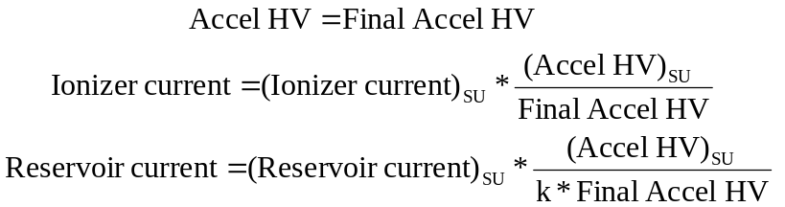

Where
- Final Accel HV is determined either by the value contained in a loaded ISF, or by editing the Start/Stop Cs Panel (See below).
- (AccelHV)_{SU}, (Ionizer current)_{SU}, (Reservoir current)_{SU} are Set-Up parameters (Refer to The Setup Reference list ). They are the current values of respectively Accel HV, ionizer current and reservoir current at the last Save or Save as operation. The can also be edited in the The Cs Source Set-up parameter main panel (See below).
- k is a cofficient which takes into account that for obtaining a given source temperature, the products (Ionizer current * Accel HV) and (Reservoir current * Accel HV) must not be exactly constant (See the physsical reason in the ion source user's guide). For low accel HV, k must be larger than 1. It is possible to edit k for the different Accel HV intervals [0, 3 kV], [3kV, 5kV], [5kV, 7kV], [7kV, 9kV], [9kV, 10 kV] in the Set-up-file . (#722-726)

For reducing the reservoir current at a given accel HV, increase in the set-up file the corresponding coefficient (#722-726)

Contents ↑

The Cs Source Start Process
The Cs source Start Process is activated in 2 cases:
- When the operator clicks START in the Start/Stop CS source panel.
- When a new ISF is loaded (See the section § Loading and Saving an ISF), if the new ISF accel HV is not the current one.
Any Cs source Start Process can be defined by the set of 3 initial parameters and 3 final parameters
Initial Accel HV | Final Accel HV
Initial ionizer current | Final ionizer current
Initial reservoir current | Final reservoir current

The initial parameters are the instrument current parameters. For the determination of the final parameters, refer to Cs Source heating current normalization.

The Slow/Fast mode test
At the beginning of the Cs Start Process , a test is firstly achieved for running the process either under the Slow mode or under the Fast mode.

Test criterion: Slow mode if
Total Cs source current < ON Threshold
Total Cs source current = ionizer + reservoir + leakage currents

The "ON Threshold" reservoir current can be edited in the The Cs Source Set-up parameter advanced panel.

The Slow mode Cs source Start Process
Step 1: The Accelerating Voltage is driven in 10 steps from its initial value (typ 0) to its final value.
Step 2: The Ionizer Current is continuously increased from its initial value (typ 0) to its final value. This heating ramp duration can be edited in the The Cs Source Set-up parameter advanced panel (Ionizer heating slope).
Step 3: Waiting time which can be edited in the The Cs Source Set-up parameter advanced panel (Ionizer Stabilization)
Step 4: The Reservoir Current is continuously increased from its initial value (typ 0) to its final value. This heating ramp duration can be edited in the The Cs Source Set-up parameter advanced panel (Reservoir heating slope).

The overall slow mode Start Process duration is typically of 600 sec.

The Fast mode of the Cs source Start Process
The set of 3 Cs source parameters (Accel HV, Ionizer current, and Reservoir current) is incremented from the initial values to the final values in 10 steps with 1 second per step.

The overall fast mode Start Process duration is 10 seconds.

Cs Source Stop Process
The Cs source Stop Process is activated in a single case, when the operator clicks STOP in the Start/Stop CS source panel.

The Slow/Fast mode test
As for the Start Process, at the beginning of the Cs Stop Process , a test is firstly achieved for running the process either under the Slow mode or under the Fast mode, but the difference between both modes is far slighter than for the Start Process.

Test criterion: Slow mode if
Total Cs source current > OFF Threshold
Total Cs source current = ionizer + reservoir + leakage currents

The "OFF Threshold" reservoir current can be edited in the The Cs Source Set-up parameter advanced panel.

The Slow mode Cs source Stop Process
Step 1: The Reservoir Current is continuously decreased from its initial value to zero. This cooling ramp duration can be edited in the The Cs Source Set-up parameter advanced panel (Reservoir cooling slope).
Step 2: Waiting time which can be edited in the The Cs Source Set-up parameter advanced panel (Reservoir waiting time)
Step 3: The Ionizer Current is continuously decreased from its initial value to zero This cooling ramp duration can be edited in the The Cs Source Set-up parameter advanced panel (Ionizer cooling slope).
Step 4: The Accelerating Voltage is driven in 10 steps from its initial value to zero.

The overall slow mode Stop Process duration is typically of 750 sec.

The Fast mode of the Cs source Stop Process
For the Stop Process, the fast mode is identical to the slow mode, except that the step 1 (long decrease of the reservoir current) is by-passed and that the reservoir current is set directly to zero.

The overall fast mode Stop Process duration is 600 seconds.

Contents ↑

The Start/Stop CS source panel
Clicking the icon in the top of the Tuning menu bar opens the property box displayed below.

☞ Select the Cs60 tab.
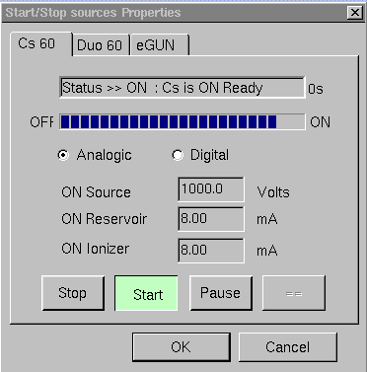 | - Analogic/digital Selection radiobutton. If Analogic, the source parameters are displayed in the box in physical units (Volts or mA). If Digital they are displayed in no-unit digits, as they are displayed in the Real Time Screen.  - ON Source Accel displays the accel HV as it is in the current ISF.  - ON Reservoir displays the reservoir current as it was at the last Stop Source, normalized according to the accel HV. See Cs Source normalization.  - ON Ionizer displays the ionizer current as it was at the last Stop Source, normalized according to the accel HV. See Cs Source normalization.
- Stop button for activating the Cs source Stop process. See above The Cs source stop process.
- Start button for activating the Cs source Start process. See above The Cs source start process.
- Pause suspends either the Stop or the Start process.
- OK for running the process.

Contents ↑

The Cs source set-up parameter panel
Click Setup at the top of the Tuning menu bar
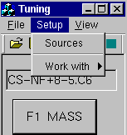

A menu lists 2 possible selections: Sources and Work with. Select Sources for opening the Source Setup property box.
The Cs Source Set-up parameter main panel
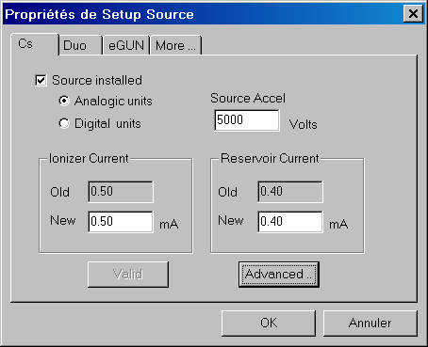

- Source installed if this check box is checked the source corresponding to the selected tab (e.g. Cs60) will be recognized by the software (e.g. menu Setup/Work with) (Setup #710)
- Analog units/digital units Selection. If Analog units, the source parameters are displayed the box in physical units (Volts or mA). If Digital units they are displayed in no-unit digits, as they are displayed in the Real Time Screen.
- Last Source Accel Edit Field. The default displayed value is the Last Valid source accel contained in the current ISF. It can be re-edited for starting the source
- Advanced opens the CS source setup parameter advanced panel.

The Cs Source Set-up parameter advanced panel
Path: Setup/Sources + Click Advanced
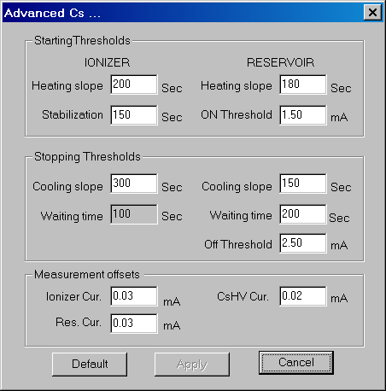

IONIZER
- Heating slope displays and edits the ionizer heating duration during the Start Cs Source Process. (set-up #727)
- Stabilization displays and edits the delay which occurs after the ionizer heating during the Start Cs Source Process. (set-up #728)
- Cooling Slope displays and edits the ionizer cooling duration during the Stop Cs Source Process. (set-up #730)
- Waiting time displays the non-programmable delay which occurs after the ionizer cooling during the Stop Cs Source Process.
RESERVOIR
- Heating slope displays and edits the reservoir heating duration during the Start Cs Source Process. (set-up #729)
- ON Threshold displays and edits the total Cs source current (reservoir + ionizer + leakage) used for the Slow/Fast test during the Start Cs Source Process. (set-up #740)
- Cooling slope displays and edits the reservoir cooling duration during the Stop Cs Source Process. (set-up #732)
- Waiting time displays and edits the delay which occurs after the reservoir cooling during the Stop Cs Source Process. (Set-up #731)
- Off Threshold displays and edits the total Cs source current (reservoir + ionizer + leakage) used for the Slow/Fast test during the Stop Cs Source Process. (Set-up #741)

MEASUREMENT OFFSETS
Inizer cur., Res Cur, Cs HV Cur (Set-up #736, 737, 738)

The Cs source links with the Setup file

# | Set-up Label | Comments
710 | Col60 Cesium present | Tuning/Setup/Source/Cs60
722 | Cs ACCEL 2KV | reservoir current normalization coefficient. [0, 3KV]
723 | Cs ACCEL 4KV | reservoir current normalization coefficient. [3, 5KV]
724 | Cs ACCEL 6KV | reservoir current normalization coefficient. [5, 7KV]
725 | Cs ACCEL 8KV | reservoir current normalization coefficient. [7, 9KV]
726 | Cs ACCEL 10KV | reservoir current normalization coefficient. [9, 10KV]
727 | Cs ionizer on ramp delay | Tuning/Setup/Source/Advanced used in the Start Process
728 | Cs ionizer heating delay | Tuning/Setup/Source/Advanced used in the Start Process
729 | Cs reservoir on ramp delay | Tuning/Setup/Source/Advanced used in the Start Process
730 | Cs ionizer OFF ramp delay | Tuning/Setup/Source/Advanced used in the Stop Process
731 | Cs reservoir cooling delay | Tuning/Setup/Source/Advanced used in the Stop Process
732 | Cs reservoir OFF ramp delay | Tuning/Setup/Source/Advanced used in the Stop Process
733 | Cs60 Power Accel HV | Tuning/Setup/Source/ last saved Accel HV
734 | Cs 60 Power Ionizer debit | Tuning/Setup/Source/ last saved Ionizer current
735 | Cs60 Power reservoir debit | Tuning/Setup/Source/ last saved Reservoir current
740 | Cs60 CSHV ON-Threshold | Tuning/Setup/Source/Advanced used in the Start Process
741 | Cs60 CSHV Reservoir OFF Threshold | Tuning/Setup/Source/Advanced used in the Stop Process

Contents ↑

The Duo Source control

Overview
The Tuning Duo Source control panels allow the operator to set the Duo Source High Voltage, Arc current and coil current and to run the procedures Duo Start Process and Duo Stop Process. The Duo Source High Voltage (or Accel HV) is choosen by the user according to analytical requirements. Both the Arc and the coil currents are not depending upon this accelerating High Voltage (Refer to The CAMECA ion source user’s guide).
It is also possible to modify the source parameters from the synoptics panel.

The Duo source Start Process
The Duo Start process is normally launched from the Duo Start/Stop panel

- Vacuum HV security test
- set arc current.
- set coil current
- Open the duo O2 leakage Valve
- waiting time (IARC delay, Setup # 754, 759)
- Test arc current : test= (measured arc current – ISF arc current)/(ISF arc current)
Where ISF arc current is the ISF value in digits multiplied by 0.024.
if (test < - Arc current tolerance), Duo Stop Process
Arc current tolerance editable in the Duo setup panel
- Set Duo HV
- waiting time (Duo HV delay, Setup # 755, 760)
- test duo HV: test= (measured duo HV – ISF duo HV)/(ISF duo HV)
if (test < - Duo HV tolerance), Duo Stop Process
Duo HV tolerance editable in the Duo setup panel
- Duo is ready

The Duo Stop Process
The Duo Stop process is normally launched from the Duo Start/Stop panel

- Close the duo O2 leakage Valve
- Set HV=0
- Set coil=0
- Set Arc=0

The Duo source Start/Stop panel
Clicking the icon in the top of the Tuning menu bar opens the property box displayed below.
- Select the Duo tab.
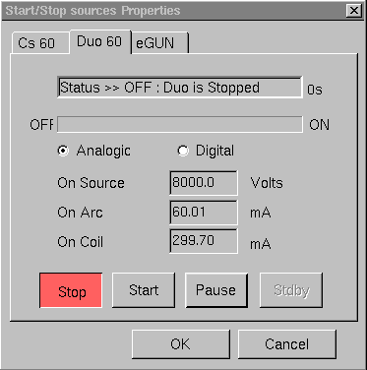 | - Analogic/digital Selection radiobutton. If Analogic, the source parameters are displayed the box in physical units (Volts or mA). If Digital they are displayed in no-unit digits, as they are displayed in the Real Time Screen.  - ON Source Accel displays the accel HV as it is in the current ISF.  - ON Arc Source displays the Arc current as it was at the last Stop Source.  - ON Coil current displays the coil current as it was at the last Stop Source.
- Stop button for activating the Duo source Stop process.
- Start button for activating the Duo source Start process.
- Pause suspends either the Stop or the Start process.
- OK for running the process.

Contents ↑

The Duo source set-up parameter panel
Click Setup at the top of the Tuning menu bar

A menu lists 2 possible selections: Sources and Work with. Select Sources for opening the Source Setup property box.

- Duo installed if this check box is checked, the source corresponding to the selected tab (e.g. Duo) will be recognized by the software (e.g. menu Setup/Work with) (Setup #711).
- Arc current Tolerance (%) edits the tolerance used in the arc Current test which is performed in the Duo Start Process. (Setup #751)
- Arc current waiting time (s) edits the waiting time included in the Duo Start Process. (Setup #754).
- Duo HV Tolerance (%) edits the tolerance used in the Duo HV test which is performed in the Duo Start Process. (Setup #752).
- Duo HV waiting time (s) edits the waiting time included in the Duo Start Process. (Setup #755).
- OK validates the modified edited fields and writes them in the Setup file.
- Cancel closes the box without taking into account the edited modifications.

Contents ↑

The Duo source links with the Setup file
# | Set-up Label | Comments
711 | Col60 Duo present | Tuning/Setup/Source/Duo60
751 | Duo60 Arc Current Tolerance | Tuning/Setup/Source/Duo60
752 | Duo60 HV Current Tolerance | Tuning/Setup/Source/Duo60
753 | Duo60 HV Restart Delay | Tuning/Setup/Source/Duo60
754 | Duo60 IARC Delay | Tuning/Setup/Source/Duo60
755 | Duo60 HV Delay | Tuning/Setup/Source/Duo60

The E-GUN Source Control

Overview
Refer to the Normal Electron Gun (NEG) user’s guide

The E-GUN Start Process

The E-Gun Start process is normally launched from the E-Gun Start/Stop panel

- Test Vacuum
- Set E-Gun HV (2")
- Set the wehnelt voltage at maxi
- Set the filament heating current
- Set the emission current (servoed by the wehnelt voltage)
- Test heating current
if(measured heating current=0), message "Filament broken"
E-gun Stop Process
- test emission current
if(measured emission current) outside ISF emission current ± Tolerance
Message "Emission current out of range"
(Tolerance= EGUN current tolerance, Setup #761)
- Message "EGUN Ready

The E-GUN Stop Process
The E-Gun Stop process is normally launched from the E-Gun Start/Stop panel

- Set the filament heating current to zero
- Set E-Gun HV to zero.
- Set all the e-gun parameters to zero (including the coils Bx, Bya and Byb)
- Message "Stop NEG completed

Contents ↑

The E-GUN Start/Stop panel
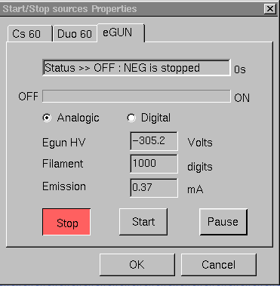
Note: at first start (normally done at the factory), one must select eGUN and Start in this panel. After that, the egun high voltage, filament and emission have to be adjusted . Finally one must click the e-BEAM ON button in the Tuning Master Panel.

The E-GUN setup parameter panel
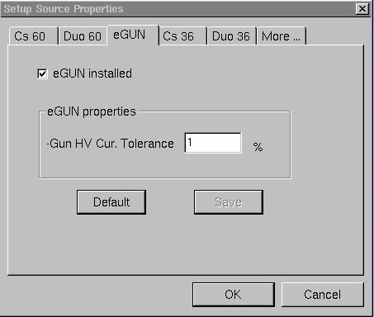
- eGUN installed : if this check box is ticked, the e-gun source will be reckognize by the software (e.g. menu Setup/Work with) (Setup #714)
- eGUN current Tolerance (%) edits the tolerance used in the eGun emission current test which is performed in the eGun Start Process. (Setup #761)
- OK validates the modified edited fields and writes them in the Setup file.
- Cancel closes the box without taking into account the edited modifications.

The E-gun source links with the Setup file
# | Set-up Label | Comments
714 | E-Gun present | Tuning/Setup/Source/E-Gun
761 | EGUN current Tolerance | Tuning/Setup/Source/E-Gun

The Tuning Reference guide

The ISF parameters list

The source parameters
Parameters stored in the ISF, available from the keyboard thumbwheels
Parameter Label | Comment
SOURCE | Duo/Cs
ACCEL HV | Souce acceleration voltage

Parameters stored in the set-up table, available from the keyboard thumbwheels
Parameter Label | Comment
ARC | Duoplasmatron arc current (if Source=Duo)
COIL | Duoplasmatron coil current (if Source=Duo)
RESERVOIR | Reservoir electron current (if Source=Cs)
IONIZER | Ionizer electron current (if Source=Cs)

Contents ↑

The primary parameters

Optional parameters are indicated in italics.

Primary parameters stored in the ISF, available from the keyboard thumbwheels
Parameter Label | Comment
LPRIM1 | Primary column first lens
LPRIM2 | Primary column second lens
LPRIM3 | Primary column third lens
LPRIM4 | Primary column fourth lens
DPRIM1 X&Y | Primary column deflector
DPRIM2 X&Y | Primary column deflector
DPRIM3a X&Y | Primary column deflector
DPRIM3b X&Y | Primary column deflector
STIG X&Y | Primary Stig XY and Primary Stig 45 deg
BEAM POS X&Y | Primary Beam Position X, Primary Beam Position Y
PBMF | Primary Beam Mass Filter
QPRIM2 | Primary column quadrupole
QPRIM4 | Primary column quadrupole
RASTER X&Y | Primary Raster
DEF_FC | Primary Faraday Cup Deflection.
LPRIM2 A X&Y | Primary beam mass filter diaphragm
LPRIM4 A X&Y | Primary beam aperture diaphragm

Primary parameters stored in the ISF, not available from the keyboard thumbwheels
Parameter Label | Comment
Normal Source HV | Last acceleration voltage involved in a VALID+Source HV
maximum field X&Y | Maximum rastered field in X and Y (Raster=4095)  Computed when VALID + Raster
Raster ON/OFF | Boolean for the primary Raster.  Set in the main Tuning menu bar
Prim Pol | Primary ion polarity (always +)

Primary parameters stored in the set-up file, available from the keyboard thumbwheels
Parameter Label | Comment
ROT X | Primary raster X rotation (Setup # 716)

Contents ↑

The secondary parameters

Optional parameters are indicated in italics.

Secondary parameters stored in the ISF, available from the keyboard thumbwheels
Parameter Label | Comment
SAMPLE HV | Sample HV, Secondary acceleration Voltage
LIMM | Immersion lens
DT FA X&Y | Secondary beam centering in the FA Plane(Transfer line)
COEF FA X&Y | coefficients for linking DT1 and DT3 in DT CA
COEF CA X&Y | coefficients for linking DT1 and DT3 in DT FA
STIG-XY , STIG-45 | Transfer line stigmator
LTR1 | 1st Transfer lens
LTR2 | 2nd Transfer lens
CONT APER X&Y | Contrast Aperture (CA)
ENT SL X&W | Entrance Slit, position and Width.
FIELD APER X&Y | Field Aperture (FA)
ESA | Spectrometer Electrostatic Sector (ESA)
LCOUP | Spectrometer Lens (Coupling line)
HC3 (SEX) | Sextupole (Coupling line)
DSP1 X&Y | Secondary beam centering at the magnet exit (Projection line)
SLIT STIG | XY Stigmator, for focusing the exit beam (Projection line)
IMA STIG XY&45 | 2 axis stigmator, for the exit beam rotation.
DT Raster X&Y | Secondary Raster, synchronized with the primary Raster.
DT ROT X&Y | Dynamic Transfer Rotation
GATE X&Y | Electronic gate dimensions
LPR1 | 1st Projection Lens
LPR2 | 2nd Projection Lens
EXIT ESA | Exit ESA
EM-DY | Switching deflector in front of FC/EM. EM Deflection
FC-DY | Switching deflector in front of FC/EM. FC Deflection
MCP X&Y | Last deflector (Projection line)
ENER SL X&W | Energy Slit position and Width
EXIT SL W | Exit Slit width

Secondary parameters stored in the ISF, not available from the keyboard thumbwheels
Parameter Label | Comment
Normal Sample HV | Last secondary voltage involved in a VALID+Sple HV
Slit/Image/FC/EM preset | Selected MCP and detection mode
max field DTR raster X&Y | Maximum DT rastered field in X and Y (Raster=4095)  Computed when VALID+Raster or VALID+DT
Dyn Transfer (Y/N) | Boolean, for DT Y/N
Electronic gate (Y/N) | Boolean, for Electronic Gate Y/N
Sec Polarity | Secondary polarity.

Secondary parameters stored in the set-up table, available from the kbd thumbwheels
Parameter Label | Comment
EM HV | EM High Voltage (Setup # 37)
EM THRES | EM discriminator threshold (Setup # 36)
FDY RPL | Secondary Faraday repeller (Setup # 773)
CP SCINT | Fluo Screen HV (Setup # 518)
DET PA HV | EM Post acceleration voltage. (Setup #38)

Contents ↑

The NEG (E-Gun) Parameters
NEG parameters stored in the ISF, available from the keyboard thumbwheels
Parameter Label | Comment
HV | NEG High Voltage
FILAMENT | Electron gun filament heating
EMISSION | NEG emission current
Le- | NEG Lens
QUAD E- | NEG Stigmator XY
DEF1 e- X&Y | NEG 1st deflector
DEF2 e- X&Y | NEG 2nd deflector
BX | Electron magnetic Def X
BY | Electron magnetic Def Y
COIL COEFF | Electron coil coupling coefficient (Byb/Bya)

NEG parameters stored in the ISF, not available from the keyboard thumbwheels
Parameter Label | Comment
Normal NEG HV | Last e-gun voltage involved in a VALID+E- HV
NEG (Y/N) | Boolean for NEG ON/OFF

Imaging Parameters
Parameters stored in the set-up table, available from the keyboard thumbwheels
Parameter Label | Comment
CCD BRGHTNSS | (Setup # 530)
CCD CNTRST | (Setup # 531)
CCD RTNTN | (Setup # 532)
RAE BRGHTNSS | (Setup # 527)
RAE CNTRST | (Setup # 528)
RAE RTNTN | (Setup # 529)
SII BRGHTNSS | (Setup # 519)
SII CNTRST | (Setup # 520)
SII RTNTN | (Setup # 521)
RAE HV | (Setup # 526)
SEI parameters (Setup # 522, 523, 524, 525) are not available for the IMS 7f .

Contents ↑

The Synoptics Reference Guide

Optional parameters are indicated in italics.

Sources

Synoptics selection | X | Z | Y
Duoplasmatron | ARC | ACCEL HV | COIL
Cs source | IONIZER | ACCEL HV | RESERVOIR

Primary column

Synoptics selection | X | Z | Y
LPRIM1 | DPRIM1 X | LPRIM1 | DPRIM1 Y
LPRIM2 | PBMF | LPRIM2
 | DPRIM2 X | LPRIM2 | DPRIM2 Y
 |  | QPRIM2
 | LPRIM2 A X | LPRIM2 | LPRIM2 A Y
LPRIM3 | DPRIM3b X | LPRIM3 | DPRIM3b Y
 | DPRIM3a X | LPRIM3 | DPRIM3ba Y
LPRIM4 | BEAM POS X | LPRIM4 | BEAM POS Y
 | D4 X | LPRIM4 | D4 Y
 | STIG X | LPRIM4 | STIG Y
 | LPRIM4_A X | LPRIM4 | LPRIM4_A Y
 | D5 S1
 | FCP REP | DEF FC | GATE Y
 | RASTER X |  | RASTER Y
 | ROT Y
Contents ↑

Secondary
Synoptics selection | X | Z | Y
Sample |  | SPLE HV
Immersion | BEAM POS X | LIMM | BEAM POS Y
Dyn. Transfer | DT RASTER X |  | DT RASTER Y
 | DT ROT X |  | DT ROT Y
Transfer | DT FA X | LTR1 | DT FA Y
 | DT CA X | LTR2 | DT CA Y
 | COEF FA X | LTR1 | COEF FA Y
 | COEF CA X | LTR2 | COEF CA Y
 | CA X |  | CA Y
 | ENT SL X |  | ENT SL W
 | FA X |  | FA Y
Spectrometer |  | LCOUP | ESA
 |  | LCOUP | SPLE HV
 | ENRG SL | LCOUP | ENRG SL W
Projection | DPR X | LPR1 | DPR Y
 | DPR X | LPR2 | DPR Y
 | STIG XY | QUAD | STIG 45
 |  |  | EXT SL
 | D MCP X |  | D MCP Y
 |  | CP SCINT
EM | EXIT ESA |  | DEM
 | EM THRES | EM HV | EM PA HV
FC | ESA EXIT |  | D FC
 |  | FC REP
Electronic gate | E GATE W |  | E GATE W

Contents ↑

NEG
Synoptics selection | X | Z | Y
e-gun | FILAMENT | EGUN HV | EMISSION
 | BX e- | BY IONS | BY e-
 | De-1 X | Le- | De-1 Y
 | De-2 X | Le- | De-2 Y
 |  | QUAD E-

RAE
Synoptics selection | X | Z | Y
RAE | DMCP X | LTR1 | DMCP Y
 | DMCP X | LTR2 | DMCP Y
 |  | RAE HV

Apertures
Synoptics selection | X | Z | Y
Apertures | CA X | LTR1 | CA Y
 | FA X | LTR1 | FA Y
 | ENT SL X |  | ENT SL W
 | ENRG SL X | LCOUP | ENRG SL W
 |  | LPR1 | EXT SL W
 | LPRIM2A X | LPRIM2 | LPRIM2A Y
 | LPRIM4A X | LPRIM4 | LPRIM4A Y

Imaging
Synoptics selection | X | Z | Y
 | RAE BRGH | RAE RTN | RAE CNTR
 | CCD BRGH | CCD RTN | CCD CNTR
 | SII BRGH | SII RTN | SII CNTR
 |  | SII RTN | GAIN

Contents ↑

The Preset Reference Guide

Primary beam, Ion beam ON/OFF, Beam Pos
List of the Primary Beam preset parameters:
X | Z | Y
 | LPRIM1
 | LPRIM1d
 | LPRIM2
DPRIM3 X | LPRIM3 | DPRIM3 Y
D4 X | LPRIM4 | D4 Y
BEAM POS X | LPRIM4 | BEAM POS Y
STIG X | LPRIM4 | STIG Y
D5 S1 | LPRIM4
Labels:
The labels are alphanumerical labels to be defined by the user. It can be for example the spot current in nA.

Beam Pos Drift correction
Clicking Beam Pos assign to the keyboard thumbwheels:

X | Z | Y
BEAM POS X | LPRIM4 | BEAM POS Y

The Tuning is then in the status Beam pos . It is possible to getout of Beam Pos either by clicking on Apply or Cancel (as explained in 2.7):
- Apply shifts all the Primary Beam preset
- Cancel does not modify any Primary Beam preset.

Ion Beam ON/OFF
Clicking Ion Beam OFF produces a continuous primary beam blanking deflection towards the primary Faraday cup FCp.

Contents ↑

Maximum area

List of the Maximum Area preset parameters:

X | Z | Y
STIG X | LIMM | STIG Y
DT_FA X | LTR1 | DT_FA Y
DT_CA X | LTR2 | DT_CA Y
COEF FA X | LTR1 | COEF FA Y
COEF CA X | LTR2 | COEF CA Y

Labels
The labels are numerical (µm) or alphanumerical
Mini=35 µm, maxi=250 µm
If the labels are numerical, they can be taken into account for the computation of the optical gate.
.

Maximum area Drift correction
Clicking Area Pos assign to the keyboard thumbwheels:

X | Z | Y
DTR X | LIMM | DTR Y

The Tuning is then in the status Area pos . It is possible to getout of Area Pos either by clicking on Apply or Cancel (as explained in 2.7):
- Apply shifts all the Max Area preset
- Cancel does not modify any Max Area preset.

Contents ↑

Raster, Raster ON/OFF

List of the Raster preset parameters:

X | Z | Y
RAST X |  | RAST Y

Labels
The Preset0 preset label est "zero" . It corresponds to RASTER X=RASTER Y=0
The Preset1 to Preset9 preset labels are numerical (µm), integer, editable. Editing a Raster label updates automatically RASTER X and RASTER Y

Action VALID + RASTER
The maximum rastered field are computed
Maximum field X = Raster_0 * (4095/RASTER_X0)
Maximum field Y = Raster_0 * (4095/RASTER_Y0)

Where Raster_0 is the current Raster preset label (in µm) and RASTER_X0 (_Y0) is the RASTER X (Y) current value at the VALID time.

Further, the parameters RASTER_X &Y will be determined by the required Raster (µm)
RASTER_X = 4095 * (Raster/ Maximum field X)
RASTER_Y = 4095 * (Raster/ Maximum field Y)

Linearity correction
Refer to the section § Raster Linearity Correction. When switching the Raster preset, the linearity correction is normally not updated.

ZOOM Mode
The ZOOM Mode can be used for the Raster preset.

ON/OFF
RASTER=OFF is equivalent to RASTER=0
Contents ↑

DTOS ON/OFF
List of the Raster preset parameters:

X | Z | Y
DT RASTER X |  | DT RASTER Y

Labels
No Label.

VALID + DTOS ON
When the DTOS ON/OFF calibration box is opened, both DT Raster X and DT Raster Y are available with the keyboard thumbwheels.

The maximum rastered field are computed
Max_field_dtr1_ X = Raster_0 * (4095/DT_Raster_X0)
Max_field_dtr1_ Y = Raster_0 * (4095/DT_Raster_Y0)

Where Raster_0 is the current Raster preset label and DT_Raster_X0 (_Y0) is the DT RASTER X (Y) current value at the VALID time.
Further, the parameters DT_Raster_X &Y will be determined by the required Raster (µm)
DT_Raster_X = 4095 * (Raster/ Max_field_dtr1_ X)
DT_Raster_Y = 4095 * (Raster/ Max_field_dtr1_ Y)

DTOS ON/OFF
When DTOS=OFF, DT Raster X =DT Raster Y = 0

Electronic gate, e-gate ON/OFF
List of the E Gate preset parameters:

X | Z | Y
E GATE W |  | E GATE W

Labels
The Preset0 preset label est "zero" (EL GATE W=0)
The Preset1 to Preset9 preset labels are numerical (%), integer, editable.

VALID
No VALID action. EL GATE W is determined by its label:
EL GATE W = 511 * Label/100

e-gate ON/OFF
e-gate = OFF is equivalent to 100% e-gate preset (EL GATE W=511)

Contents ↑

Presets MCP_Image et MCP_Slit, FC et EM
The instrument has 3 possible exclusive main status MCP/RAE/DET
- If STATUS=MCP, 2 exclusive sub-status SLIT/IMAGE and 10 presets for each substatus.
- If STATUS=DET, 2 exclusive sub-status FC/EM
- If STATUS=RAE, 2 exclusive sub-status SLIT/IMAGE and 10 presets for each substatus.

MCP corresponds to an ion image on the MicroChannelPlate, RAE is slightly different, it corresponds to the case of a RAE device replaces the MCP. DET corresponds to the case of measuring the ion signal with a FC or EM detector.

A VALID action on the –th MCP_SLIT preset validates both the common parameters of MCP and the parameters associated to the –th preset of MCP_SLIT.

MCP_Image et MCP_Slit Presets

Parameters associated to MCP (identical for both MCP_SLIT and MCP_IMAGE)

EXIT ESA=0, PARAM_DET=2, DP3 X&Y

Parameters associated to SLIT or IMAGE (identical for respectively all the MCP_SLIT presets and all the MCP_IMAGE presets)

LCOUP, QUAD, IMA STIG XY&45, HC3

Parameters contained within the 10 MCP_SLIT presets or the 10 MCP_IMAGE presets

LPR1, LPR2

List of the SLIT or IMAGE preset parameters:

X | Z | Y
 | LCOUP
STIG X | LPR1 | STIG Y
 | LPR2
 | QUAD

Labels
Alphanumerical, editable

Clicking SLIT or IMAGE
When clicking SLIT, the MCP parameter values, i.e. EXIT ESA, PARAM_DET, DP3 X&Y are loaded. Then, The common SLIT parameter values, i.e. LCOUP, SLIT STIG, IMA STIG XY&45 are loaded and at finally, the parameter values specific to the current SLIT preset, LPR1 and LPR2 are loaded.
When clicking IMAGE, the MCP parameter values, i.e. EXIT ESA, PARAM_DET, DP3 X&Y are loaded. Then, The common IMAGE parameter values, i.e. LCOUP, SLIT STIG, IMA STIG XY&45 are loaded and at finally, the parameter values specific to the current IMAGE preset, LPR1 and LPR2 are loaded.

When switching only the preset number, without switching SLIT/IMAGE, only LPR1 and LPR2 are updated.

VALID
The VALID action is standard: parameter current values are stored respectively in the MCP preset, in the SLIT or IMAGE preset and in the –th SLIT or IMAGE preset.
Contents ↑

FC and EM Presets
Parameters associated to DET (identical for both FC and EM)

EXIT ESA, LPR1, LPR2

Parameters identical to MCP_SLIT

LCOUP, QUAD, IMA STIG XY&45, HC3

Parameters depending on FC/EM

FC: PARAM_DET=0
EM: PARAM_DET=1

Depending on the FC/EM selection, the Y thumwheel will be assigned to FC-DY or EM-DY. The PARAM_DET value will determine the beam switching towards the Faraday cup or the EM.

List of the EM and FC preset parameters:

X | Z | Y
 | (LCOUP)
ESA EXI | LPR1 | D EM (or FC)
(STIG X) | LPR2 | (STIG Y)
 | (QUAD)

Note: Parameters between brackets appear in the definition box but are not saved in the presets. The presets use for these parameters the values read from the SLIT presets.

No Label

No VALID

Contents ↑

E-GUN ON/OFF
parameters contained in the preset

EMISSION, DEF1 e-X

Labels
Alphanumerical, editable

VALID
Standard

E-Gun ON/OFF
OFF (egun=0): DEF1 e-X= 4095, EMISSION=0
ON(egun=1): DEF1 e-X and EMISSION current values.

Contents ↑

Motorized Aperture presets (Optional)
These presets are accessed by the F1 MASS button in the Tuning main menu bar (§2.1).
There are 5 motorized aperture presets:
- Entrance Slit (ENT S)
- Contrast Aperture (CA)
- Field Aperture (FA)
- Energy Slit (ENER S)
- Exit Slit
All of them have a Drift Correction function which allows to apply the same difference of setting for all the presets of a given type.

Entrance slit
Parameters contained within the preset

ENT SL X

The 9 Entrance Slit presets are pre-programmed at the same values as the MR default table (refer to the section § Mass resolution)

K_{m}*0.67/300 | K_{m}*0.67/600 | K_{m}*0.67/1200
K_{m}*0.67/2000 | K_{m}*0.67/3000 | K_{m}*0.67/4000
K_{m}*0.67/5000 | K_{m}*0.67/6000 | K_{m}*0.67/10000

K_{m} is the mass dispersion coefficient. It is stored in the det-up file. For the IMS Wf and SC-Ultra, it is close to 250000 µm.

Label
Numerical (µm), not editable.

No VALID, No Calib

Contrast Aperture

Parameters contained within the preset

CONT APER X&Y

4 presets corresponding to the 4 apertures mounted on the CA bar.

Labels
Numerical (µm), not editable. They are stored and editable in the set-up table

Default values
# | Label | CONT APER X | CONT APER Y
1 | 400 µm | 100 | 0
2 | 150 µm | 100 | 2800
3 | 50 µm | 100 | 5600
4 | 20 µm | 100 | 8400

VALID
Standard

Contents ↑

Field Aperture
Parameters contained within the preset

FIELD APER X&Y

4 presets

Labels
Numerical (µm), not editable. They are stored and editable in the set-up table.

Default values
# | Label | FIELD APER X | FIELD APER Y
1 | 1800 µm | 600 | 500
2 | 1200 µm | 600 | 4000
3 | 750 µm | 600 | 7500
4 | 400 µm | 600 | 11000

VALID
Standard

Energy slit
Parameters contained within the preset

ENER SL X&W

9 presets

Labels
Numerical (eV), not editables according to the formula

Label (eV) = ENER SL W * Normal Sample HV/ K_{e}

Where the energy dispersion coefficient K_{e}=170000 (µm)
ENER SL W is expressed in µm.

Default values
Label for 5keV | (Max) | (30) | (15) | (12) | (10) | (5) | (2.5) | (0.75) | 0
ENER SL X | -1000 | -100 | -100 | -100 | -100 | 0 | 0 | 0 | -100
ENER SL W | 4950 | 1020 | 510 | 408 | 340 | 170 | 85 | 25 | 0
ENER SL X and ENER SL W are in µm

VALID
Standard

Contents ↑

Exit Slit
Parameters contained within the preset

EXIT SL W

9 presets

EXIT SL W value is determined by the formula

EXIT SL W (µm) = (K_{m} /Label)

Where the mass dispersion coefficient K_{m} is stored in the set-up file. For the IMS Wf and SC-Ultra, it is close to 250000 µm.

The 9 presets are preprogrammed as for the MR table default value. (refer to the section § Mass resolution) i.e. 300, 600, 1200, 2000, 3000, 4000, 5000, 6000, 10000.

Label
Numerical, expressed in MR, not editable.

No VALID, No Calib

Mass resolution
Parameters contained within the preset

ENT SL W, EXIT SL W, ENER SLIT PRESET

Note that ENER SLIT PRESET is a number of Energy Slit preset

9 presets

EXIT SL W value is determined by the formula
EXIT SL W (µm) = (K_{m} /Label)

Where the mass dispersion coefficient K_{m} is stored in the set-up file. For the IMS Wf and SC-Ultra, it is close to 250000 µm.

Labels
Numerical, editable.

Default values
MR Preset | Label | Entrance Slit  (µm) | Energy slit
1 | 300 | 555 | #1
2 | 600 | 278 | #1
3 | 1200 | 139 | #1
4 | 2000 | 83 | #1
5 | 3000 | 55 | #3
6 | 4000 | 42 | #5
7 | 5000 | 33 | #5
8 | 6000 | 28 | #5
9 | 8000 | 21 | #5

VALID
Standard, but the interface is not standard.

ENT SL W default value is determined by the formula
entrance_slit_w (µm) = 0.67*(K_{m} /MR)

The Raster Linearity Correction
Not yet written

The indexation reference guide

Valid + Source Accel HV
(X means a linear update)
ISF Parameters available from the kbd thumbwheel
Parameters | firmware | Updating
Primary Def1 X | dprim1_dx | X
Primary Def1 Y | dprim1_dy | X
Primary Def2 X | dprim2_dx | X
Primary Def2 Y | dprim2_dy | X
Primary Def3a X | dprim3a_dx | X
Primary Def3a Y | dprim3a_dy | X
Primary Def3b X | dprim3b_dx | X
Primary Def3b Y | dprim3b_dy | X
Primary Stig XY | dprim4_s1 | X
Primary Stig 45 deg | dstpr4_s2 | X
Primary Beam Position X | beam_pos_x | X
Primary Beam Position Y | beam_pos_y | X
Primary LPRIM1 | lprim1 | X
Primary LPRIM2 | lprim2 | X
Primary LPRIM3 | lprim3 | X
Primary LPRIM4 | lprim4 | X
Primary Beam Mass Filter | dprwien_coil | Square Root
Primary Raster X | raster_x | X
Primary Raster Y | raster_y | X
Primary Farady Cup Def | def_fc | X
PBMF Diaph X | lprim2_diaphragm_x | No
PBMF Diaph Y | lprim2_diaphragm_y | No
Prim. Aperture Diaph X | lprim4_diaphragm_x | No
Prim. Aperture Diaph Y | lprim4_diaphragm_y | No
Duo Accel | laccel | No

ISF parameters not available from the kbd thumbwheels
Parameters | firmware name | Updating
Normal Source HV | last_valid_source_hv | -
maximum field x | Raster_max_x | 1/(Source Accel)
maximum field y | Raster_max_y | 1/(Source Accel)
polarité source primaire | pol_prim | No

Valid + Sample HV
(X means a linear update)
Only the kbd available ISF parameters are updated by VALID + Sample HV

Parameters | firmware name | Updating
Sample HV | sample_hv | -
Immersion lens | limm | X
Transfer Def X | dtr1_dx | X
Transfer Def Y | dtr1_dy | X
Transfer Stigmator XY | sttr2_s1 | X
Transfer Stigmator 45deg | sttr2_s2 | X
Transfer Lens 1 | ltr1 | X
Transfer Lens 2 | ltr2 | X
Contrast Diaph X | contrast_diaphragm_x | No
Contrast Diaph Y | contrast_diaphragm_y | No
Entrance slit X | entrance_slit_x | No
Entrance slit W | entrance_slit_w | No
Field Aperture X | field diaphragm_x | No
Field Aperture Y | field diaphragm_y | No
Main ESA X | esa1 | X
Spectrometer Lens | lcoup | X
Projection Def X | dsp1_dx | X
Projection Def Y | dsp1_dy | X
Projection Slit Stig XY | dsp1_s1 | X
Project. Image Stig XY | sp2_s1 | X
Project. Image Stig 45d | sp2_s2 | X
Dynamic transfer X | dtr1_raster_x | X
Dynamic transfer Y | dtr1_raster_y | X
Dynamic transfer rotation | dtr1_rotate_x | No
EM Gate width W | e_gate_size | No
Projection Lens 1 | lpr1 | X
Projection Lens 2 | lpr2 | X
Exit ESA | esa_det | X
Switch EM Def Y | sw_dy_em | X
Switch FC Def Y | sw_dy_fc | X
EM Post acceler. Voltage | em_pa | No
Projection last Def X | dp3_dx | X
Projection last Def Y | dp3_dy | X
Energy slit position X | energy_slit_x | No
Energy slit width W | energy_slit_w | No
Exit slit width W | exit_slit_w | No

Contents ↑

The Tuning setup file parameters
Some parameters are available from the Tuning synoptics panel and can be tuned with the dedicated keyboard thumbwheels but are not stored in the ISF but in the Setup file.

Parameter Label | Comment | # setup file | typ value  (digits)
RESERVOIR | Reservoir electron current (if Source=Cs) | 735 | 103
IONIZER | Ionizer electron current (if Source=Cs) | 734 | 802
ROT X | Primary X last deflection rotation | 716 | 0
EM HV | EM High Voltage | 37 | 2452 (1)
EM THRES | EM discriminator threshold | 36 | 100
FDY RPL | Secondary Faraday repeller | 773 | 400
CP SCINT | Fluo Screen HV | 518 | 2458
DET PA HV | EM Post acceleration voltage. | 38 | -
CCD BRGHTNSS |  | 530 | 3404
CCD CNTRST |  | 531 | 2048
CCD RTNTN |  | 532 | 0
RAE BRGHTNSS |  | 527 | -
RAE CNTRST |  | 528 | -
RAE RTNTN |  | 529 | -
SII BRGHTNSS |  | 519 | 4095
SII CNTRST |  | 520 | 3912
SII RTNTN |  | 521 | 0
RAE HV |  | 526 | -
(1) beginning of EM life

